Multimedia Systems and Applications

Edge Detection

- Write a program using the language (Matlab, C++,…) you are familiar with to detect the edges from an image
- The images are at the end of this document.
- Basic issues
    - Histogram equalization
飛機
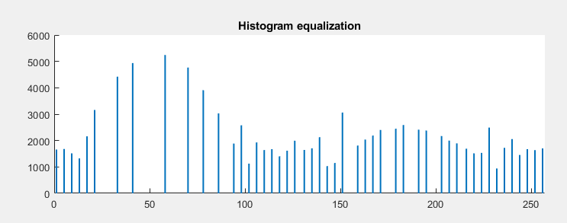
蜘蛛
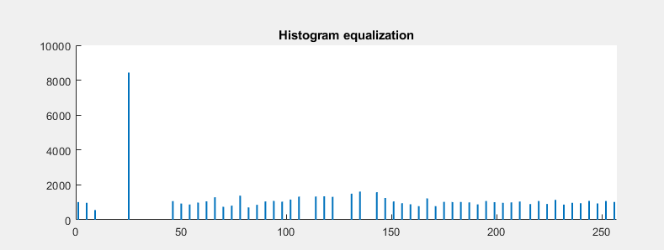
    - Sobel operator
飛機
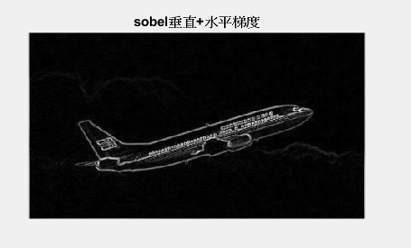
蜘蛛
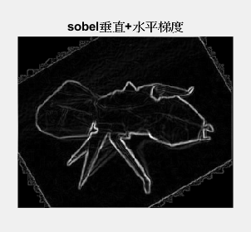
    - Add your comments in source code
      - The goal of the function, the main concept of the code section, the meaning of each variable, …
%a. Histogram equalization

file= imread('input1.png');%讀檔
gray=rgb2gray(file);%轉成灰階

[M N]=size(file);%M:row N:col
N=N/3;%N包含RGB 3個col，只需要1個代表col

subplot(3,2,1),imshow(gray);
title('ì¹Ï');

[counts,x]=imhist(gray);%imhist對gray進行植方圖統計，counts:灰階值個數，x: 灰階值1~256
P=counts/(M*N);%P:每個灰階值出現的機率

accumulate=counts;%accumulate:累計灰階值個數
for i=2:256
accumulate(i)=accumulate(i)+accumulate(i-1);
end

H=im2double(gray);%轉乘double
location=find(counts~=0);%找pixel個數不為0的灰階值

MinCDF=min(counts(location));% pixel個數最少的灰階值

for j=1:length(location)

CDF=sum(counts(location(1:j)));%各灰階值的累積個數

P=find(H==x(location(j)));%找影像中某灰階值的所在位置

H(P)=(CDF-MinCDF)/(M*N-MinCDF);%修改該位置的灰階值

end

subplot(3,2,2),hold on;
A=histeq(H);
[counts,x]=imhist(A);
bar(counts);
%plot(accumulate);
title('Histogram equalization');
hold off;

%H=A;

%b. Sobel operator

gx=[-1 -2 -1; 0 0 0; 1 2 1]; %ℎ𝑜𝑟𝑖𝑧𝑜𝑛𝑡𝑎𝑙 𝑒𝑑𝑔𝑒
gy=[-1 0 1; -2 0 2; -1 0 1]; %𝑣𝑒𝑟𝑡𝑖𝑐𝑎𝑙 𝑒𝑑𝑔𝑒
gradx=filter2(gx,H,'same'); %濾波
gradx=abs(gradx); %絕對值
subplot(3,2,3);
imshow(gradx,[]);
title('sobel垂直梯度');

grady=filter2(gy,H,'same');
grady=abs(grady);
subplot(3,2,4);
imshow(grady,[]);
title('sobel水平梯度');

grad=gradx+grady;
subplot(3,2,5);
imshow(grad,[]);
title('sobel垂直+水平梯度');

- Bonus
以飛機的圖為例，觀察sobel梯度的圖可發現沒有Histogram equalization的邊界判定結果較好

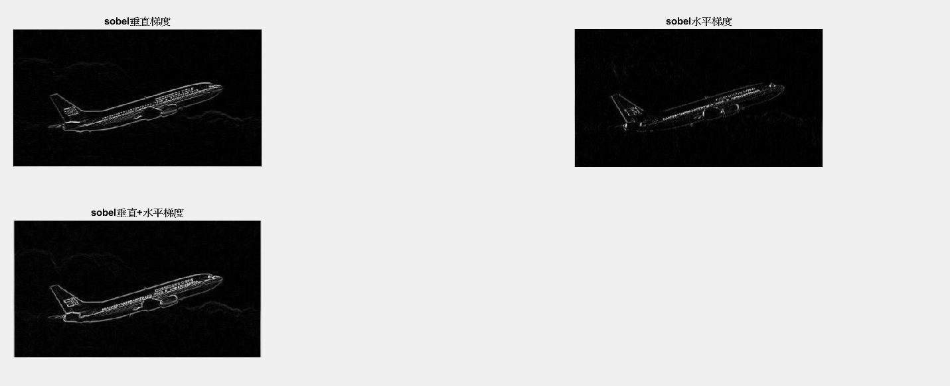
(圖一):沒有Histogram equalization
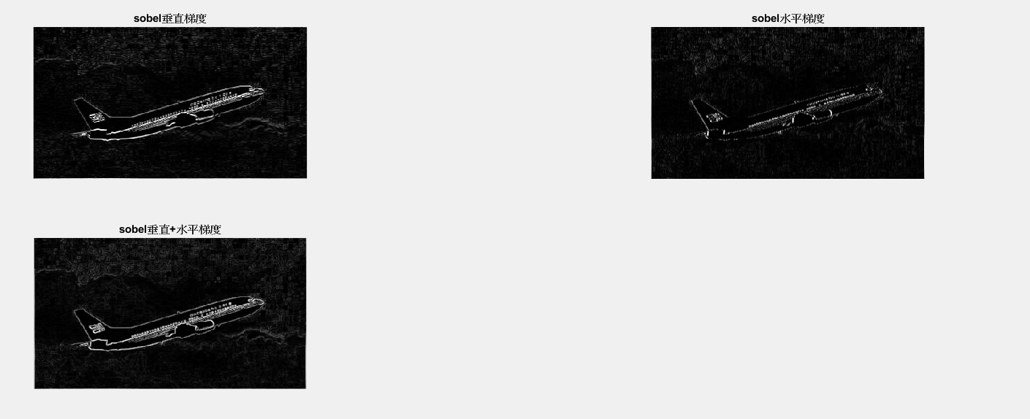
(圖二):有Histogram equalization

